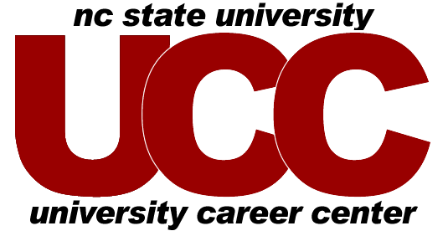

SAMPLE INTERVIEW QUESTIONS
TO ASK

When an employer asks if you have questions, the answer is yes! Prepare a few questions in advance so you will be ready. Do you have to wait to be asked? No -- some interviews are highly interactive and questions are welcomed throughout. Follow the cues of your interviewer who will guide you.

- Could you describe a typical assignment of a summer intern?
- Could you tell me about a project the group is currently working on?
- How would you describe the working environment?
- What are the unique challenges of this particular job.
- I have read about the mentoring program on your website. Could you tell me more?
- What are you looking for in a new hire?
- Do you provide a structured training program or will I learn on the job?
- What opportunities exist for professional development?
- What career paths are available to someone with my major?
- Is an advanced degree valued at your company?
- Are there opportunities for continued education?
- Are there opportunities to move within the company in the future – different sites, departments, positions?
- Could you tell me the process and timeframe for performance evaluations?
- What are the organization's plans for future growth?
- What makes the company stand out in its industry?
- What do you enjoy most about working for this company?
- Please tell me about your career path at the company.
- What qualities do successful hires in your organization share?

Updated 2009

